PROJECT JARINGAN DAN KOMUNIKASI

PRIVATE CHAT

MEMBER:

GERRY SUCITPO/00000012157

SUDONO TANJUNG/00000012273

SAMUEL TEGUH/00000012383

MARCEL CAHYA PRASETIA/00000019043

FERONIA MEILINDA/00000012566

VERI GUNAWAN/00000012343

RICKHEN HERMAWAN/00000012311

HENDRIAN LUNARDI/00000012778

BRYAN YEHEZKIEL/00000016528



UNIVERSITAS PELITA HARAPA

TEKNIK INFORMATIKA

1. **TimeTable**

|  |  |  |
| --- | --- | --- |
| Day / Time | Activity | Description |
| 24/03/2017 | Meeting | Want to know about source code about client and server |
| 27/03/2017 | Meeting | what must we do to adding feature |
| 31/03/2017 | Private chat (Whisper) | Adding private chat as whisper |
| 4/04/2017 | Online User | Show online user after on of client has been disconect |
| 10/04/2017 | Send files privately | Send file certainly to specific client |
| 6/04/2017 | Modifying JLabel (“Techworld3g”) | Modify JLabel(“techworld3g”) to client name |
| 11/04/2017 | Modify Server and Client GUI | Modify GUI to make more tidy |
| 15/04/2017 | Fixed send file privately | The latest file send only send file that are only coverted to string and now the client can |
| 17/04/2017 | Show online user in GUI | Show list of users who are online |

1. **Work Division**

GitHub link : https://github.com/sudtanj/Client-Server_Chat

* Gerry Sucipto :

1. Coding for feature number 2 and 3
2. Coordinate all groub member
3. Help to make ppt and doc for project assignment

* Sudono Tanjung

1. Coding for feature number 1
2. Help to make ppt and doc for project assignment

* Samuel Teguh

1. Coding for feature number 4
2. Help to make ppt and doc for project assignment

* Bryan Christofel

1. Helps with the coding work of feature number 4
2. Make PPT
3. Learn the theories that are related to chat client server

* Hendrian Lunardi

1. Helps with the coding work of feature number 2
2. Make PPT
3. Learn the theories that are related to chat client server

* Feronia Meilinda

1. Helps with the coding work of feature number 1
2. Make PPT
3. Learn the theories that are related to chat client server

* Veri Gunawan

1. Helps with the coding work of feature number 4
2. Make Doc
3. Learn the theories that are related to chat client server

* Marcel Cahya Prasetia

1. Helps with the coding work of feature number 4
2. Make Doc
3. Learn the theories that are related to chat client server

* Rickhen Hermawan

1. Helps with the coding work of feature number 1
2. Make Doc
3. Learn the theories that are related to chat client server
4. **Feature Already Included**

* Private chat to specific user by typing the format (/w [username] [chat])
* Show online User before and after user Disconect
* Different name per client Frame
* Send file to specific user
* Show Online user in server GUI

1. **What Feature that are already included?**

* Show online user in server GUI

1. **Technical Gains**

* Ability to add whispering system to the program
* Ability to display online user
* Ability to change JLabel (Swing Component)
* Ability to do socket programming
* Ability to open connection port
* Ability to know how to show online user in GUI

1. **Step Running the Chat**

Typing NetBeans or Eclipse in Windows search bar and open it.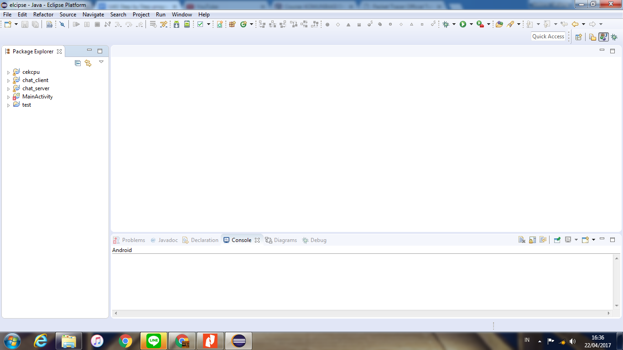

Click File => Open Projects and find your project in your directory

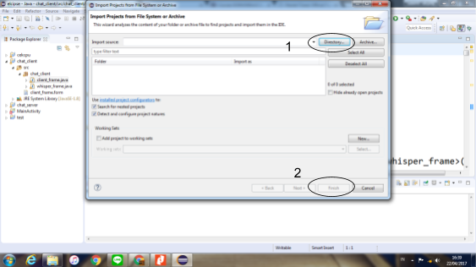

Once the project is fully loaded, the file that has extension .java will appear on screen with the code

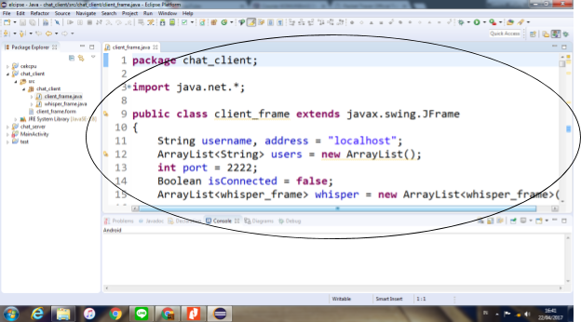

Choose the server_frame.java and click run button as example below

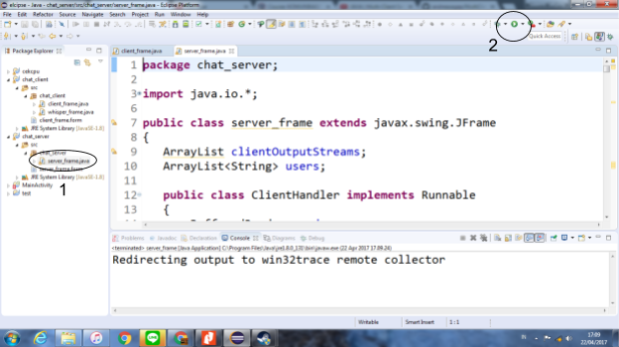

Click the start button as example below

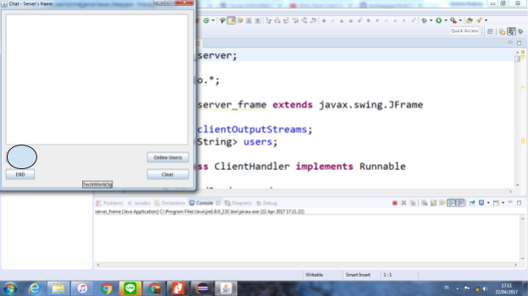

Choose the client_frame.java and click run button as example below

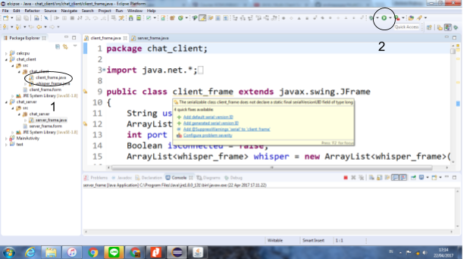

Type the username in the username box provided and click connect

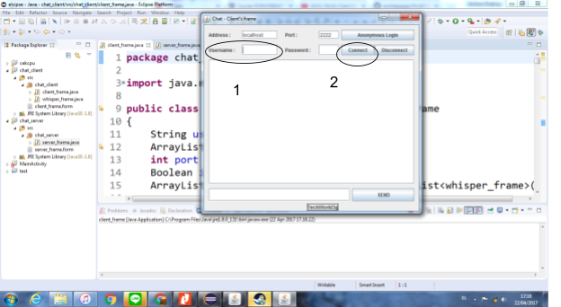

Whisper

After connected, please type /w [username] [message] then click send

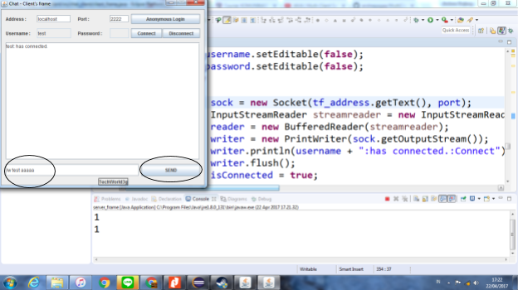

Attach File

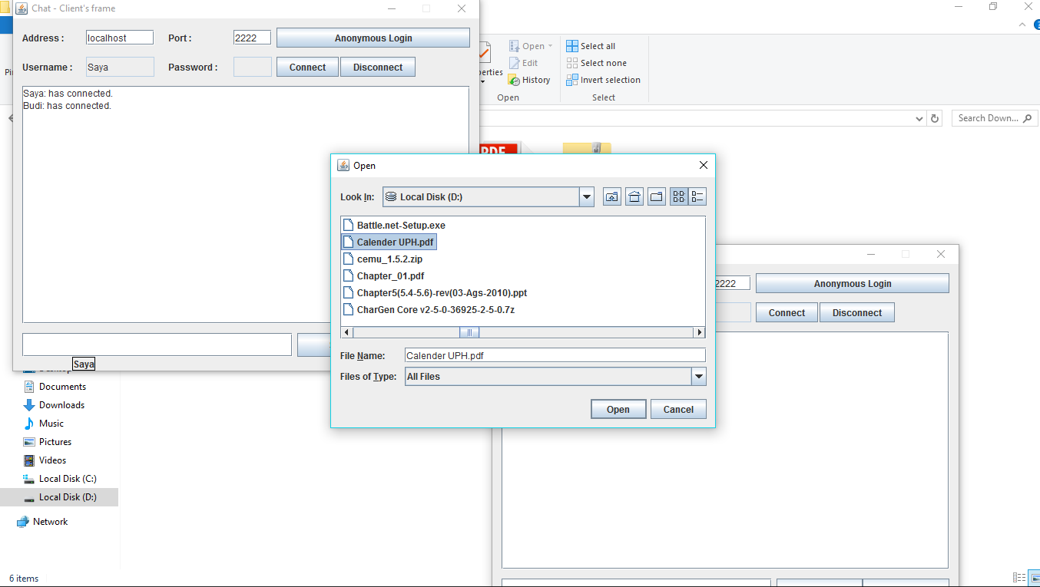Click Attach and choose the file you want to send

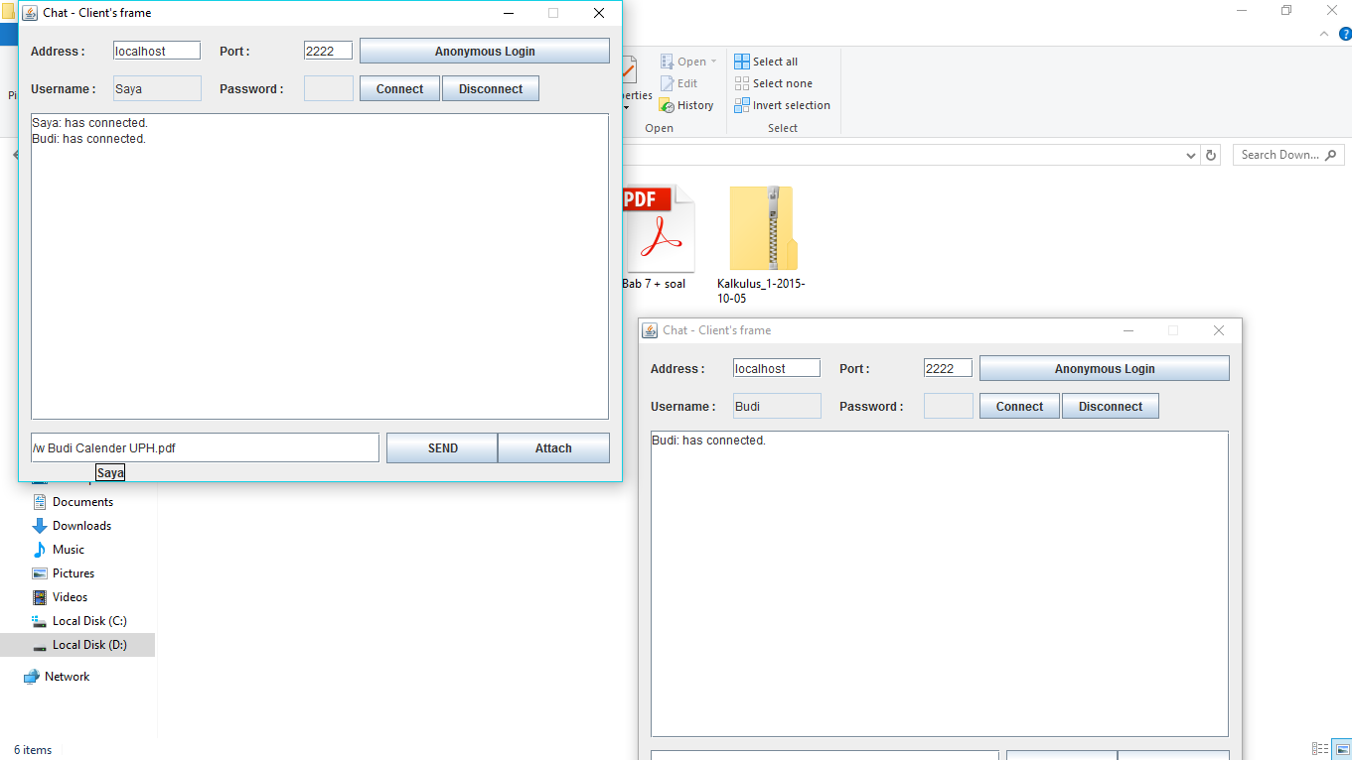Replace [username target here] with the username you want to send the file to and Click Send

1. **Feature ScreenShoot**

* Change “TechWord3g” label to user name

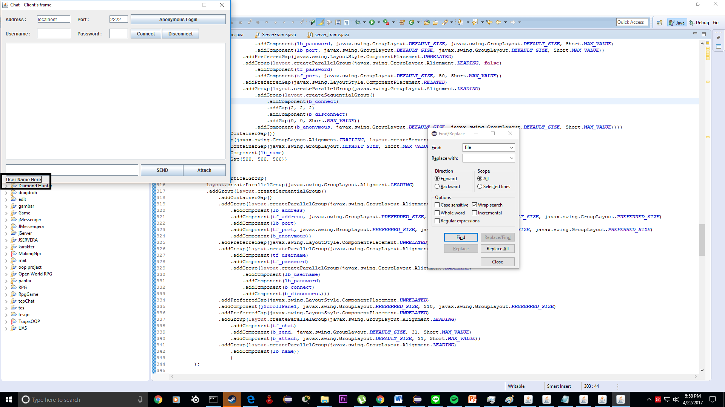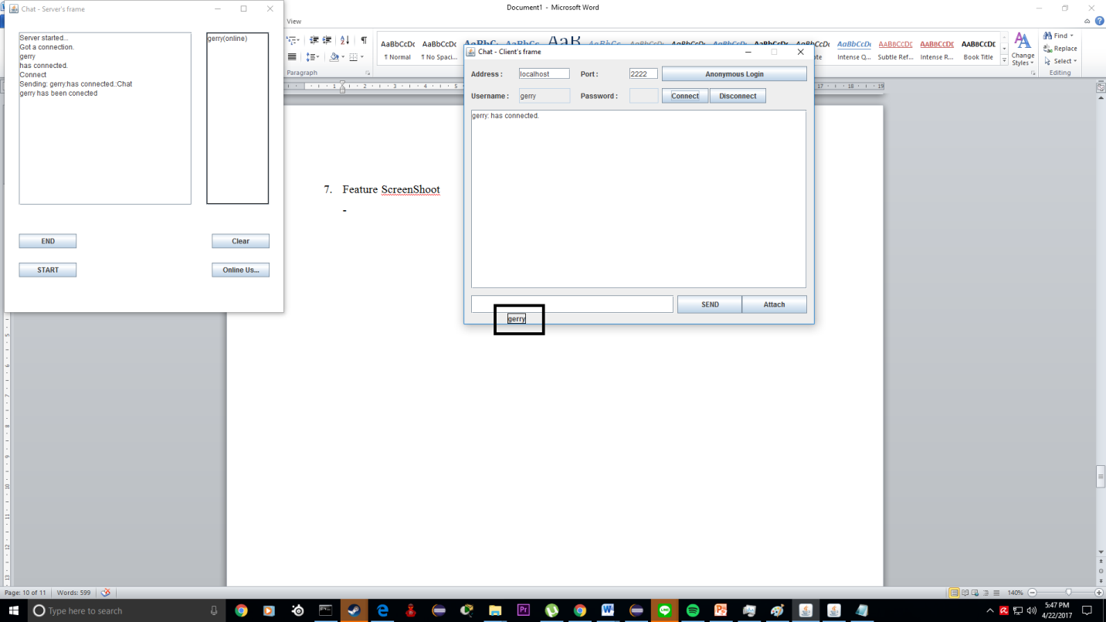

Description : after user connected to server label automaticly changed to user name

* Send chat to specific user

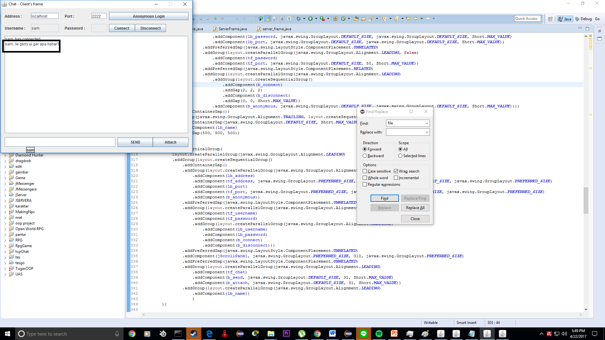

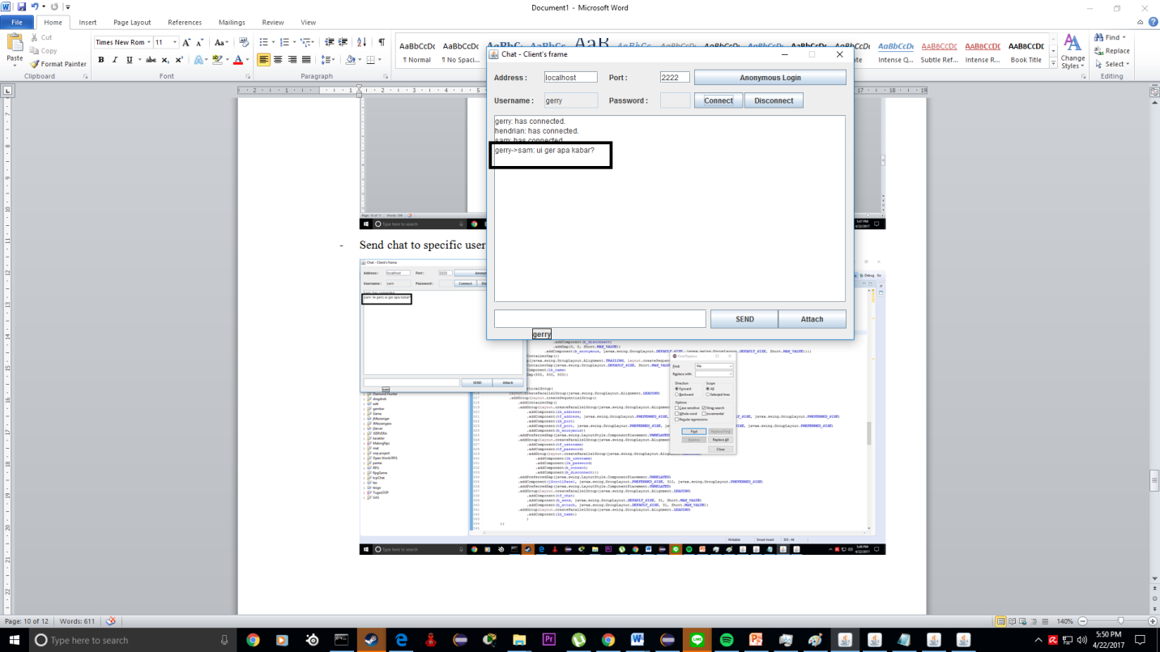

Description: can privately send chat to specific user by typing format /w [name] [chat]. In the screenshot above is shown that sam send a message to gerry

* Show online user in GUI

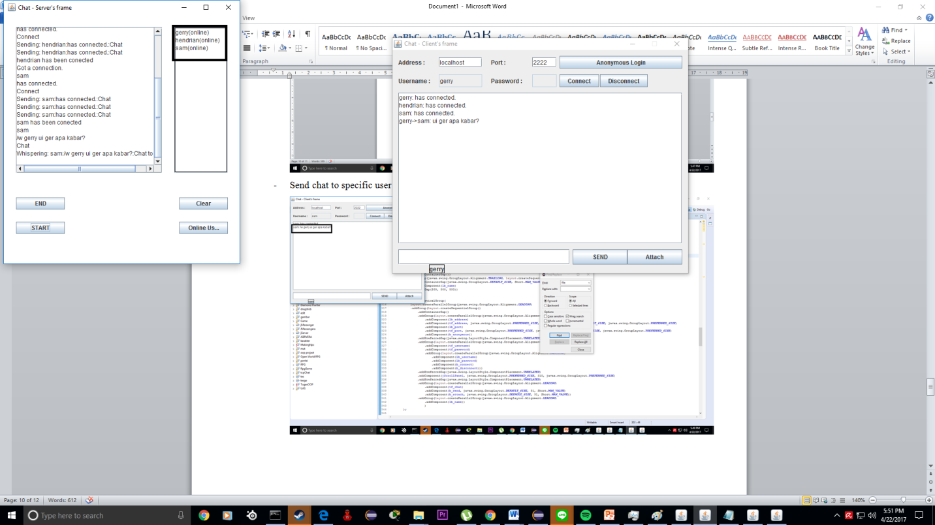

Description: In the GUI server shown there are 3 user online gerry, sam and hendrian

* 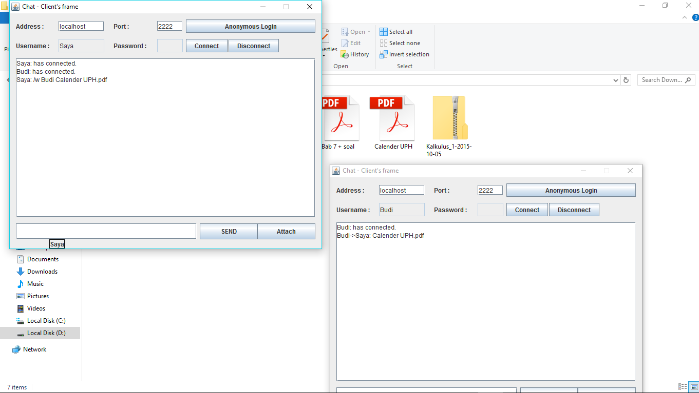Send File to specific user

1. Why we are satisfied with our program

Why we are satisfied with our program? Because we already add requested feature in our program with our maximum effort. Even the send attachment feature that we though we won’t be able to do it. So in our opinion our program make us satisfied.

Refrence

<https://docs.oracle.com/javase/7/docs/api/java/net/Socket.html>

<http://www.citethisforme.com/>

<https://docs.oracle.com/javase/7/docs/api/java/io/InputStream.html>

<http://stackoverflow.com/questions/9265719/print-arraylist>

<https://www.tutorialspoint.com/java/java_networking.htm>

<https://docs.oracle.com/javase/tutorial/networking/sockets/>

https://docs.oracle.com/javase/7/docs/api/java/io/FileOutputStream.html